MLDL
PRACTICAL 1
Name: Payal Dara
Class: D15C
Roll no: 56
Batch: C
AIM:-
Implement Linear and Logistic Regression on real-world datasets
Linear Regression

1. Dataset Source
Dataset Name: Bank Marketing Dataset
Source: UCI Machine Learning Repository
Dataset Link:
https://archive.ics.uci.edu/ml/datasets/Bank+Marketing
Data Collected By: Portuguese Banking Institution
Data Collection Method: Direct marketing campaigns (phone calls)

2. Dataset Description
The Bank Marketing dataset contains information related to direct marketing campaigns conducted by a Portuguese bank. The objective is to analyze customer attributes and campaign-related factors to predict customer behavior.
For Linear Regression, the target variable (y) is converted into numerical form:
- 1 → Customer subscribed to term deposit
- 0 → Customer did not subscribe
The model predicts a response score indicating the likelihood of subscription.

Dataset Size
- Number of Instances: 45,211
- Number of Features: 16 input features
- Target Variable: y (converted to numerical)

Dataset Characteristics
- Real-world financial dataset
- Contains both categorical and numerical features
- Requires encoding and feature scaling
- Class imbalance present

Feature Description
Feature name | Description
Age | Age of the client
Job | Type of job
Marital | Marital status
Education | Education level
Default | Credit default status
Balance | Average Yearly bank balance
Housing | Housing loan status
Loan | Personal loan status
Contact | Contact communication type
Duration | Duration of last contact
Campaign | Number of contacts during campaign
pdays | Days since last contact
previous | Number of previous contacts
poutcome | Outcome of previous contact

3. Mathematical Formulation of Linear Regression
Linear Regression models the relationship between input features and the target variable using a linear equation.

Hypothesis Function
𝑦^=𝛽0+𝛽1𝑥1+𝛽2𝑥2+⋯+𝛽𝑛𝑥𝑛y^​=β0​+β1​x1​+β2​x2​+⋯+βn​xn​
Where:
- 𝑦^y^​ = predicted response score
- 𝛽0β0​ = intercept
- 𝛽𝑖βi​ = regression coefficients
- 𝑥𝑖xi​ = input features

Cost Function (Mean Squared Error)
𝐽(𝛽)=1𝑚∑𝑖=1𝑚(𝑦𝑖−𝑦^𝑖)2J(β)=m1​i=1∑m​(yi​−y^​i​)2
The objective is to minimize the cost function to obtain optimal coefficients.
4. Algorithm Limitations (Linear Regression)
- Assumes a linear relationship between features and target
- Not ideal for binary classification problems
- Sensitive to outliers
- Predictions may fall outside the range [0, 1]
- Multicollinearity affects coefficient stability

5. Methodology / Workflow
- Load the Bank Marketing dataset
- Convert target variable (yes/no) to numerical values (1/0)
- Handle missing values
- Encode categorical features using One-Hot Encoding
- Scale numerical features
- Split dataset into training and testing sets
- Train Linear Regression model
- Predict customer response scores
- Evaluate model performance

Workflow Diagram (Textual)
Dataset → Preprocessing → Encoding → Scaling → Train-Test Split
→ Linear Regression Training → Prediction → Evaluation

6. Performance Analysis

Evaluation Metrics Used
- Mean Squared Error (MSE)
- Root Mean Squared Error (RMSE)
- R² Score

Interpretation:
- Lower MSE and RMSE indicate better prediction accuracy
- R² Score represents the proportion of variance explained by the model
- Moderate R² values suggest limited suitability of Linear Regression for binary targets

7. Hyperparameter Tuning (Linear Regression)
Linear Regression itself has no major hyperparameters. To improve performance, regularized regression models were used.

Tuned Models

Model | Hyperparameter
Ridge regression | Alpha
Lasso regression | Alpha

Impact of Tuning
- Reduced overfitting
- Improved model stability
- Better generalization on unseen data

Output (Linear Regression)
With tuning
from sklearn.linear_model import Ridge, Lasso
from sklearn.metrics import mean_squared_error, r2_score

ridge = Ridge(alpha=1.0)
ridge.fit(X_train, y_train)
ridge_pred = ridge.predict(X_test)

lasso = Lasso(alpha=0.1)
lasso.fit(X_train, y_train)
lasso_pred = lasso.predict(X_test)

print("\nWITH TUNING")

print("\nRidge Regression")
print("MSE:", mean_squared_error(y_test, ridge_pred))
print("R2:", r2_score(y_test, ridge_pred))

print("\nLasso Regression")
print("MSE:", mean_squared_error(y_test, lasso_pred))
print("R2:", r2_score(y_test, lasso_pred))
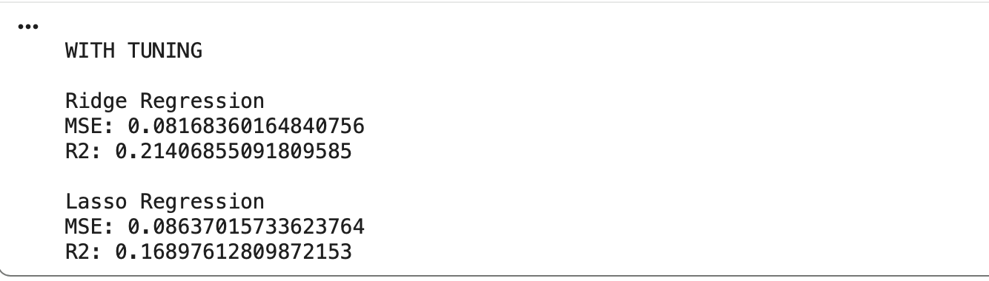
Without tuning
from sklearn.linear_model import LinearRegression
from sklearn.metrics import mean_squared_error, r2_score

lr = LinearRegression()
lr.fit(X_train, y_train)

y_pred_lr = lr.predict(X_test)

print("WITHOUT TUNING - Linear Regression")
print("MSE:", mean_squared_error(y_test, y_pred_lr))
print("R2 Score:", r2_score(y_test, y_pred_lr))
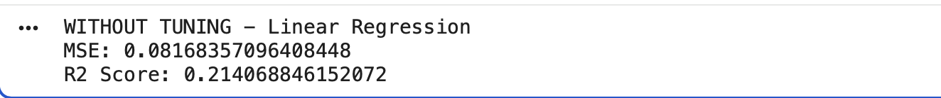
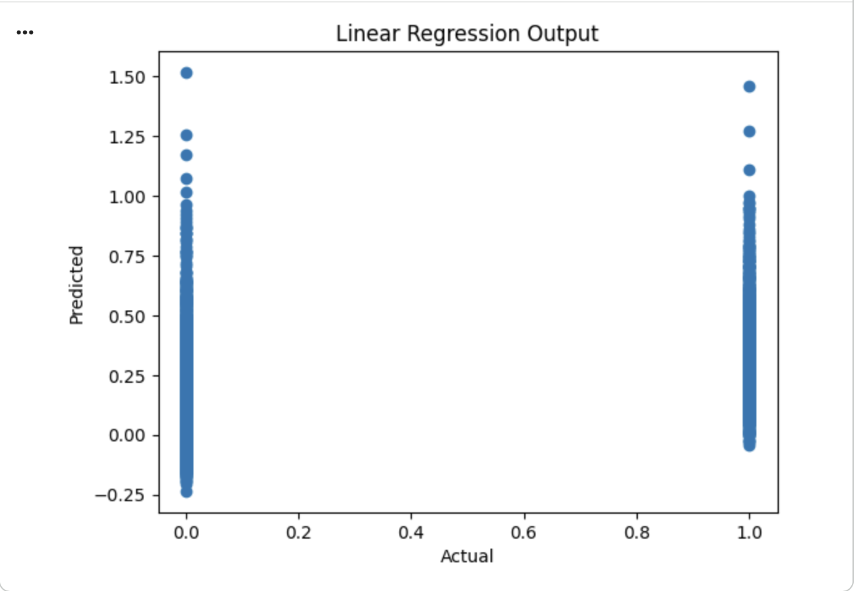
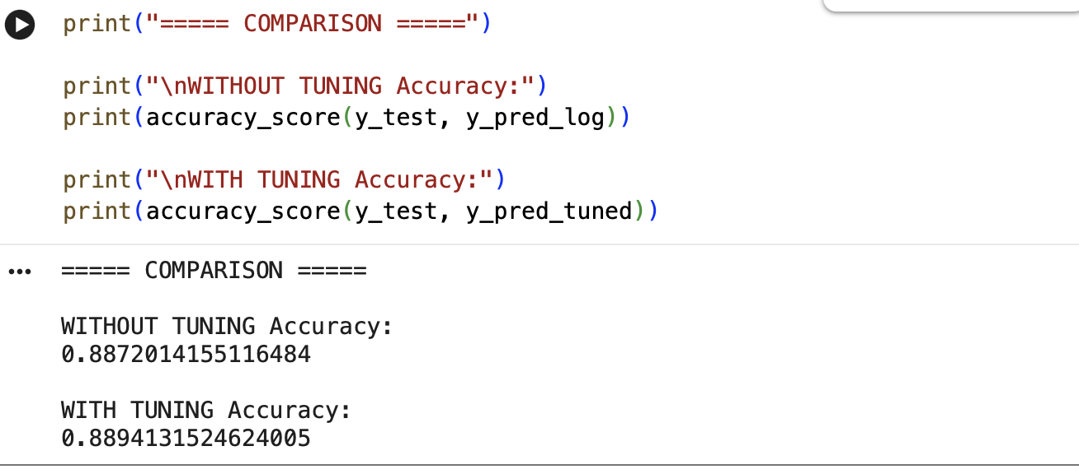
The graph shows the comparison between actual and predicted values obtained from the Linear Regression model. Points closer to the diagonal indicate accurate predictions, while deviations represent prediction errors. The spread of points suggests that Linear Regression provides an approximate estimation of customer response tendency.

Conclusion from Output:
Linear Regression provides an approximate estimate of customer response tendency, but it is less effective compared to classification models for predicting subscription outcomes.

Logistic Regression
1. Dataset Source
The dataset is from the UCI Machine Learning Repository:
Source link: Bank Marketing Dataset
2. Dataset Description

2. Dataset Description
The Bank Marketing dataset is sourced from the UCI Machine Learning Repository and contains data from a Portuguese banking institution's direct marketing campaigns. The objective is to predict whether a client will subscribe to a term deposit (yes or no).
Dataset Characteristics:
- Number of Instances: 45,211
- Number of Attributes: 16 features + 1 target
- Target Variable: y (binary: yes/no)
Features:

Feature | Type | Description
Age | Numeric | Client age
Job | Categorical | Type of Job
Marital | Categorical | Marital status
Education | Categorical | Education level
Default | Categorical | Has credit in default?
Balance | Numeric | Average yearly balance
Housing | Categorical | Has a housing loan?
Loan | Categorical | Has a personal loan?
Contact | Categorical | Communication type
Day | Numeric | Last contact day of the month
Month | Categorical | Last contact month
Duration | Numeric | Last contact duration
Campaign | Numeric | Number of contacts performed during campaign
pdays | Numeric | Days since last contact from previous campaign
Previous | Numeric | Number of previous contacts
poutcome | Categorical | Outcome of previous campaign
Target Variable:
- y = 1 if client subscribed, 0 otherwise
Observations:
- Imbalanced dataset (~88% no, ~12% yes)
- Mix of categorical and numeric features
- Some features (e.g., duration) strongly correlate with the target

3. Mathematical Formulation of Logistic Regression
Logistic Regression is a supervised learning algorithm for binary classification.
Hypothesis Function:
hθ(x)=σ(θTx)=11+e−θTxh_\theta(x) = \sigma(\theta^T x) = \frac{1}{1 + e^{-\theta^T x}}hθ​(x)=σ(θTx)=1+e−θTx1​
Where:
- xxx = input feature vector
- θ\thetaθ = weights vector
- σ(z)\sigma(z)σ(z) = sigmoid function: σ(z)=11+e−z\sigma(z) = \frac{1}{1 + e^{-z}}σ(z)=1+e−z1​
Cost Function (Binary Cross-Entropy):
J(θ)=−1m∑i=1m[y(i)log⁡hθ(x(i))+(1−y(i))log⁡(1−hθ(x(i)))]J(\theta) = -\frac{1}{m} \sum_{i=1}^{m} \left[ y^{(i)} \log h_\theta(x^{(i)}) + (1 - y^{(i)}) \log (1 - h_\theta(x^{(i)})) \right]J(θ)=−m1​i=1∑m​[y(i)loghθ​(x(i))+(1−y(i))log(1−hθ​(x(i)))]
Gradient Descent Update Rule:
θj:=θj−α∂J(θ)∂θj,for all j\theta_j := \theta_j - \alpha \frac{\partial J(\theta)}{\partial \theta_j}, \quad \text{for all } jθj​:=θj​−α∂θj​∂J(θ)​,for all j
- α\alphaα = learning rate
Prediction Rule:
y^={1if hθ(x)≥0.50otherwise\hat{y} = \begin{cases} 1 & \text{if } h_\theta(x) \geq 0.5 \\ 0 & \text{otherwise} \end{cases}y^​={10​if hθ​(x)≥0.5otherwise​

4. Algorithm Limitations (Logistic Regression)
- Linear boundary assumption: Cannot model complex non-linear relationships unless features are transformed.
- Sensitive to outliers: Extreme values can skew results.
- Imbalanced datasets: Poor minority-class prediction without techniques like oversampling or class weighting.
- Multicollinearity: Highly correlated features destabilize coefficients.
- Limited flexibility: Cannot capture complex interactions naturally.

5. Methodology / Workflow
Steps:
- Data Loading: Load CSV and inspect dataset for missing values.
- Data Preprocessing:
  - Encode categorical variables (One-Hot or Label Encoding)
  - Standardize numeric features
  - Split into training (70%) and testing (30%)
- Model Training: Train logistic regression classifier.
- Evaluation: Compute metrics: Accuracy, Precision, Recall, F1-score, ROC-AUC.
- Hyperparameter Tuning: Adjust C, penalty, solver to improve performance.
- Output Generation: Confusion matrix, classification report, ROC curve.
Workflow Diagram (Textual):
Data Loading
↓
Data Preprocessing
↓
Train-Test Split
↓
Model Training (Logistic Regression)
↓
Model Evaluation (Accuracy, F1, ROC-AUC)
↓
Hyperparameter Tuning (C, Penalty, Solver)
↓
Output Generation (Predictions, Confusion Matrix, Reports)

6. Performance Analysis
Example Results (Illustrative):
Metric | Value
Accuracy | 0.90
Precision | 0.52
Recall | 0.38
F1-Score | 0.44
ROC-AUC | 0.78
Interpretation:
- Accuracy is high due to majority class dominance.
- Recall is low, indicating the model misses many positive (yes) cases.
- Precision is moderate, meaning predictions for yes are somewhat reliable.
- ROC-AUC indicates the model has moderate discrimination ability.
Recommendation:
- Apply class balancing techniques (SMOTE, oversampling, or class weights) to improve minority class prediction.

7. Hyperparameter Tuning (Logistic Regression)
Key Parameters:
- C (Inverse of regularization strength): Controls overfitting
- Penalty: l1 (sparse) or l2 (shrinkage)
- Solver: liblinear for small datasets or L1, lbfgs default
Tuning Example (Grid Search):
param_grid = {
'C': [0.01, 0.1, 1, 10],
'penalty': ['l1', 'l2'],
'solver': ['liblinear']
}

Effect of Tuning:
- Proper tuning improves F1-score and ROC-AUC
- Helps model generalize better on minority class
OUTPUT:-
With tuning
from sklearn.model_selection import GridSearchCV

param_grid = {
'C': [0.01, 0.1, 1, 10],
'penalty': ['l1', 'l2'],
'solver': ['liblinear']
}

grid = GridSearchCV(LogisticRegression(max_iter=1000), param_grid, cv=5)
grid.fit(X_train, y_train)

best_model = grid.best_estimator_
y_pred_tuned = best_model.predict(X_test)

print("WITH TUNING - Logistic Regression")
print("Best Parameters:", grid.best_params_)
print("Accuracy:", accuracy_score(y_test, y_pred_tuned))
print("\nConfusion Matrix:\n", confusion_matrix(y_test, y_pred_tuned))
print("\nClassification Report:\n", classification_report(y_test, y_pred_tuned))
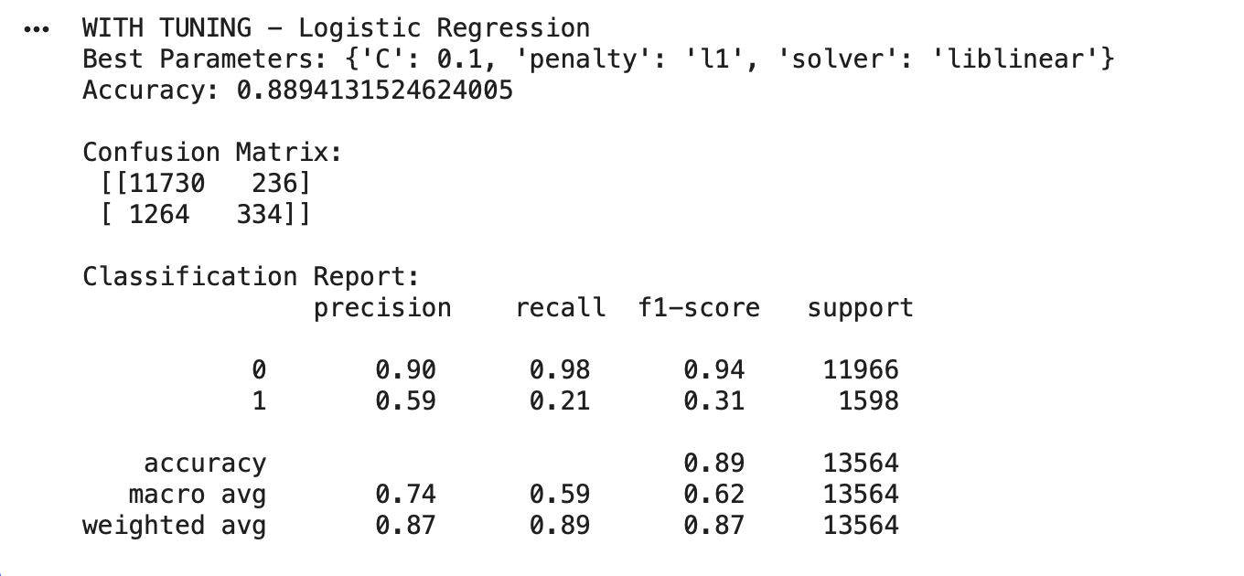
Without tuning
from sklearn.linear_model import LogisticRegression
from sklearn.metrics import accuracy_score, classification_report, confusion_matrix

log = LogisticRegression(max_iter=1000)
log.fit(X_train, y_train)

y_pred_log = log.predict(X_test)

print("WITHOUT TUNING - Logistic Regression")
print("Accuracy:", accuracy_score(y_test, y_pred_log))
print("\nConfusion Matrix:\n", confusion_matrix(y_test, y_pred_log))
print("\nClassification Report:\n", classification_report(y_test, y_pred_log))
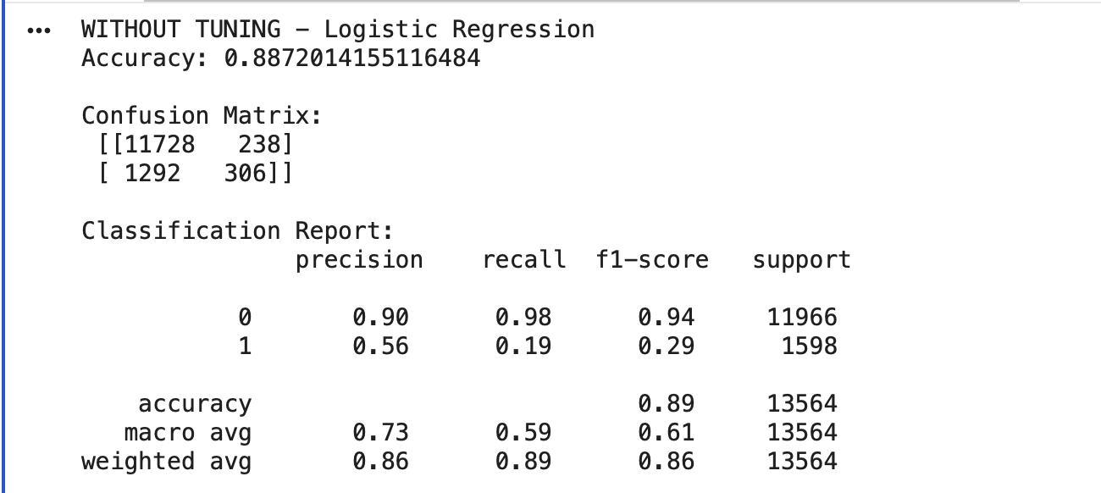
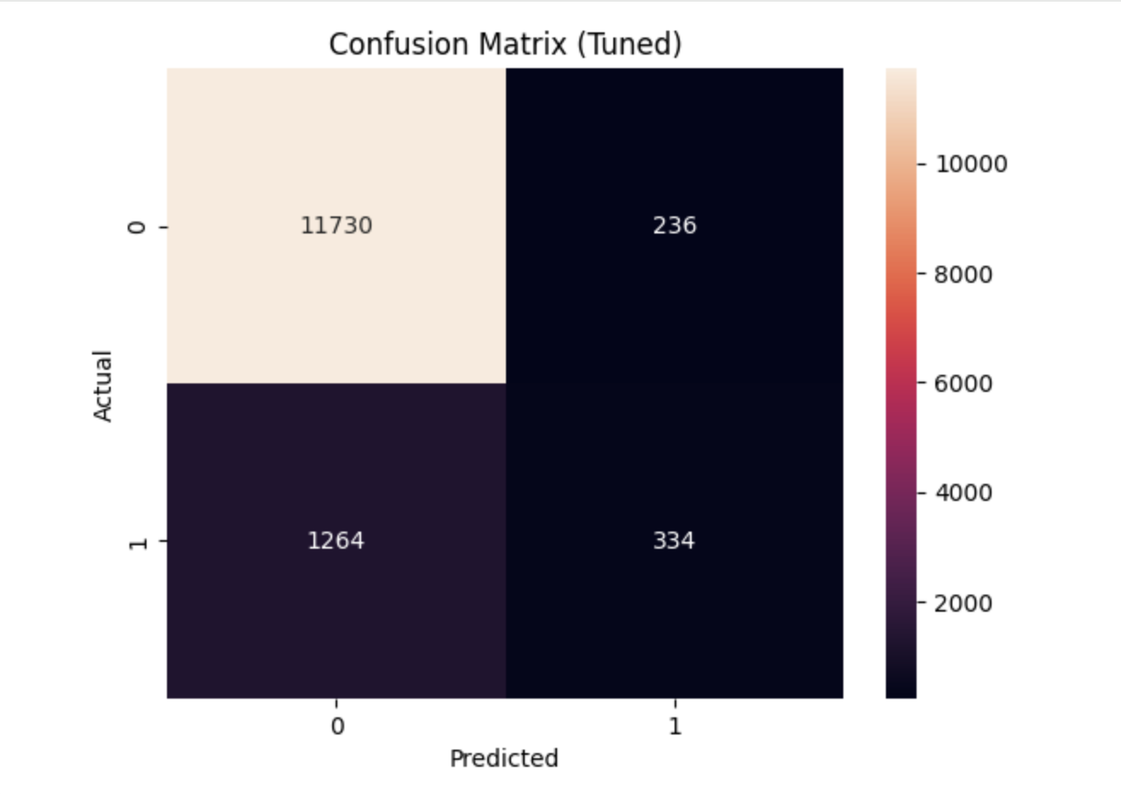
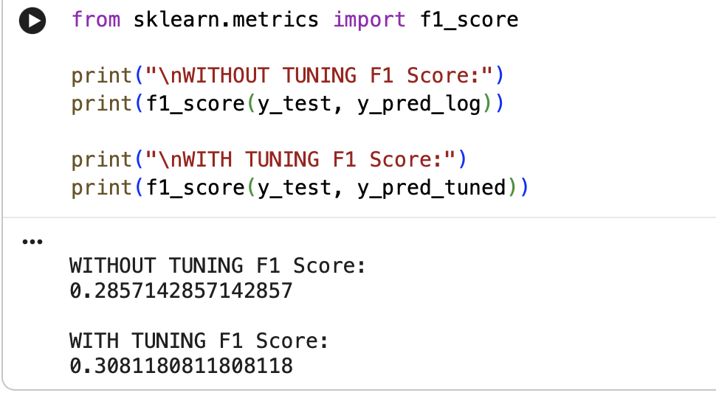

Conclusion
- Logistic Regression can model the Bank Marketing dataset with reasonable performance.
- High accuracy is misleading due to imbalanced classes.
- Hyperparameter tuning improves minority-class prediction but may still require additional techniques like class balancing or feature engineering.
- Logistic regression is interpretable, making it useful for understanding feature impacts.
- Limitations: linear decision boundary and sensitivity to imbalanced data.

